Name: ___________________________ ( ) Class: 2( )
Date: ____________________________
Worksheet 3

Title of the book: Let’s go to the beach

- Word Hunting
Can you find these words from the book. Write them down in the boxes.

b__ __ __ __  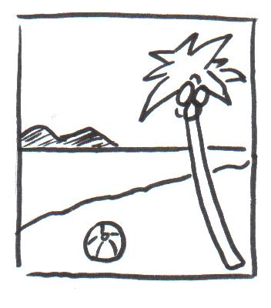  On page 4 | l __ __ __ __ __  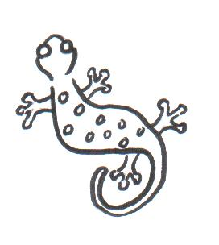  On page 7 | s__ __ __ __  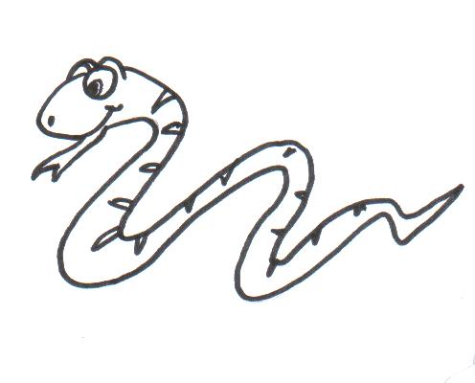  On page 9 | f __ __ __    On page 10

- Answer the questions.

- I this book.

- Who is the main character in this story?

The main character is _________________________________________.

- Where are the children going to?

They are going to _____________________________________________________.

- There are ______________ and __________________ on the beach.
( cactus / water / monkeys / waves )

Signature : ___________________
Date : ___________________

